|  |
| --- |
| Sense Welsh Logo with taglineSense Welsh LogoSense Logo with taglineSense Logo |

Virtual Buddying Advert Text

# Initial Settings for this type of Portal =

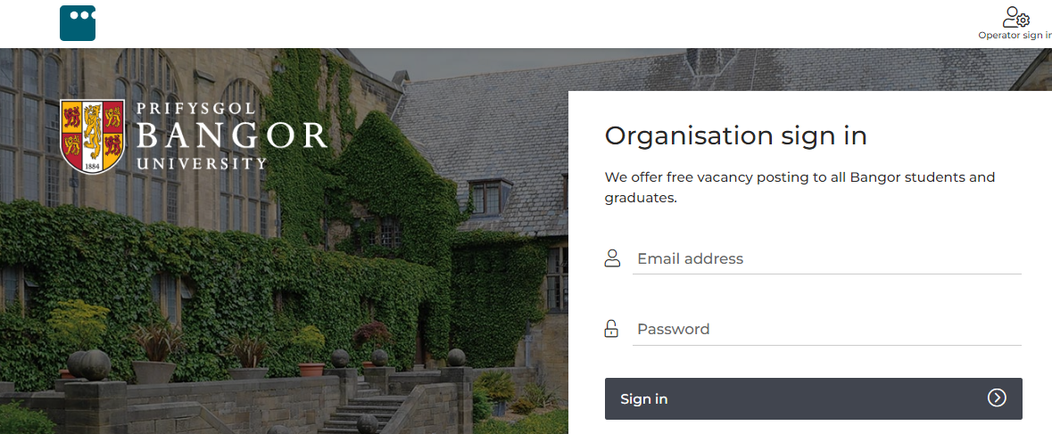

Opportunities >> Post opportunity +

**Opportunity management =** Post Locally:

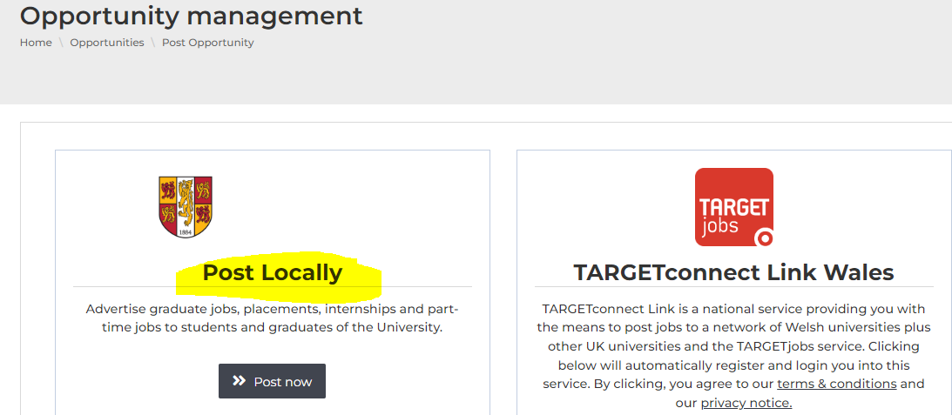

**Advertising date =** Please select the date you are adding the advert

**Listing expiry / expiry date =** Not all sites have an expiry date – if they do, please set an expiry date of 31/03/2023

**Send email notifications? =** The main contact for this vacancy only

**Application details / how do you want applicants to apply? =** Direct URL – **Application URL:** https://www.sense.org.uk/get-involved/volunteering-with-sense/volunteer-as-a-sense-virtual-buddy/

# Generic Role Information

*This can be used across all the portals in various formats. Please read the headings on the portal and select the most appropriate text / information from the headings listed below. Some of the information has been split down to relate to the specific headings on individual portals.*

*When you copy and paste information into some portals, some will reject the formatting e.g. where there are bullet points included. If this happens, go into the text box, remove the formatting e.g. bold and bullet points, and add the formatting in again using the portal formatting options e.g. bold and bullet points.*

**Role title =** Sense Virtual Buddy Volunteer

**Opportunity type / contract type =** Volunteering

**Themes =** Children and Young People, Supporting Adults

**Area of interest / job category / activity types =** Disability, Health & Social Care, Charity, Communication, Social / Personal & Child care, Buddying, Friendship, Befriending, Mentoring

**Locations / place =** Virtual, from home

**Employability skills =** Communication skills: verbal and non-verbal, interpersonal skills, organisation

**Email contact =** [volunteer@sense.org.uk](mailto:volunteer@sense.org.uk)

**Minimum hours commitment =** 90 minutes per week, for three months

**Duration (sliding scale option) =** 3 months

**Opportunity times = 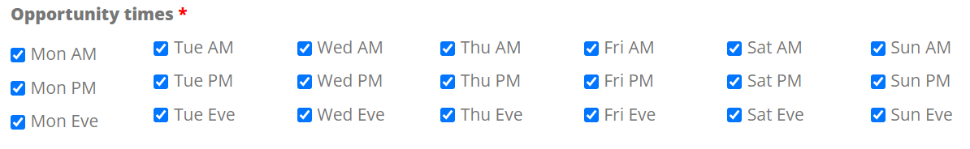Duration =** Long term opportunity

**Remote work type =** Virtual – via video call or phone

**Minimum experience required =** Good communication skills

**Activity dates =** From now. Leave open-ended if possible. If you must enter an expiry date, use 31/03/2023

**Start date / display dates =** Enter today’s date. If free text, enter, ‘Once onboarding checks and training are complete’

**Archiving date / deadline for applications =** 31/03/2023

### Description of the Role / Role Summary

**Sense Virtual Buddying volunteers make a real difference to supporting young people and adults who may be lonely or isolated.**

Sense matches volunteers with disabled people to meet for an hour a week on Zoom or over the phone.

Our volunteers have spent thousands of hours with their buddies — learning new skills, having fun, and forming fantastic friendships.

Sense matches each volunteer with someone who has similar interests, to make sure you have a great time.

You and your buddy choose a time that suits you, and you can decide what activities you’d like to do together.

Here’s what Bethany has to say about volunteering as a Virtual Buddy: “I just know that on a Thursday I’m going to be laughing at the end of my day. It’s a really positive part of my week.”

### The Role of the Volunteer / More Information

Sense matches each volunteer with someone who has similar interests to ensure you’ll have lots of fun together. Once matched with a buddy, you will get to know each other remotely via video calls or phone calls.

You’ll arrange weekly sessions and plan fun things to do together – what this looks like will be inspired by your mutual interests. You could be gaming, doing arts and crafts, playing music, seed planting – there are so many possibilities! We will provide you with weekly themed activities to help to support you in planning your interactions with your buddy.

We’ll also keep in touch with you to ensure you have all the support you need.

The programme is open to all volunteers who are 16 and over. You don't need to have previous experience volunteering or caring for disabled people. We welcome people from all backgrounds and with all interests.

### How we will Support You / What we can Offer You

Before you start your volunteering role, we’ll make sure that you’ve had the training you need to feel confident. This will be delivered online and via video call.

While you’re volunteering with us as a Virtual Buddy, you’ll get:

* A written account of your volunteering and references if required
* Access to additional communication courses such as Deaf Awareness and British Sign Language
* Reimbursement of pre-agreed expenses

Volunteering as a Sense Virtual Buddy is a great opportunity to develop new skills and get to know new people whilst making a real difference to a person’s life.

### Who we are Looking For / Skills & Qualities for the Role

*[If this is a tick box option, the kind of things to select are: communication skills, positive attitude, planning/organisation*

*If this is a box to enter text, please enter the below: ]*

We need positive, empathetic volunteers who are passionate about supporting people with complex disabilities to communicate and experience the world. We are looking for volunteers who are great communicators and who are friendly, enthusiastic, positive and ready to have fun!

We’re also always looking for volunteers who have knowledge or experience of British Sign Language (BSL) and/or other communication methods like Makaton.

We’d love for you to consider joining us as a Sense Virtual Buddy!

**Details of any training you offer =** Full training will be provided before you start volunteering you ensure you feel confident in your role. Training includes:

Safeguarding,

Equality, Diversity & Inclusion,

Confidentiality & Data Protection.

Training is also tailored specifically to support you in your role as a Virtual Buddy. We are also able to offer you additional e-learning to gain an understanding of different methods of communication (this is optional).

**Benefits to self =** Volunteering is a great opportunity to develop new skills, experiences and meet new people. In particular, you'll gain experience of working with people with disabilities and develop a new friendship.

**Benefits to others =** Sense Virtual Buddying volunteers make a real difference to supporting young people and adults who may be lonely or isolated.

**Transport details =** Remote volunteering from home

**Time commitment =** This is an ongoing opportunity – we ask volunteers to commit to a weekly session for at least 3 months.

**Support =** You will be fully supported by our team, both before you start and during your time volunteering with us.

**Expenses =** We will reimburse any pre-agreed expenses you incur.

### Other Information

**Is there a risk assessment in place? =** Yes

**Will you provide induction and training? =** Yes

**Is a DBS required? =** Yes, if your buddy is under 18 years old

**Are references required? =** Yes

**Are volunteer expenses available? =** Yes

**Can reasonable adjustments be made regarding additional needs =** Yes

### How to Apply / What the Application Process Looks Like

This section will depend on how each individual website works, so please use your judgement here as to what is the appropriate information to include (some sites will not allow you to link to an external application form and it will need to all be done through the portal).

Thank you for your interest in volunteering as a Sense Virtual Buddy! By becoming a Sense volunteer you’ll be doing something hugely rewarding and will make a big difference by supporting people with complex disabilities. Further details about this role can be found on our [website](https://www.sense.org.uk/support-us/volunteer/volunteer-as-a-sense-virtual-buddy/).

To apply:

* Fill in the application form - <http://bttr.im/9ex4s>
* We’ll invite you to an informal virtual interview and carry out reference checks
* Once you’ve been accepted, we’ll send you all the details of the training you’ll need to do
* Then we’ll match you with a buddy! ½/
* If your buddy is under 18 years old, we’ll also carry out a Disclosure & Barring (DBS) check
* If you have any questions, please contact the Volunteering Team at [volunteer@sense.org.uk](mailto:volunteer@sense.org.uk)

We really look forward to hearing from you!

### Acknowledging Application / Bounce back Response

Thank you so much for your interest in volunteering as a Sense Virtual Buddy. By becoming a Sense volunteer you’ll be doing something hugely rewarding and will make a big difference by supporting people with complex disabilities.

**Next Steps**

A member of the Sense Volunteering Team will be in touch soon to share the next steps in considering your application to join us as a volunteer.

Thank you once again for your interest in volunteering at Sense!

Current covid rules and restrictions apply.